https://{hostname}:{port}/api/talents

Get all talents’ details

Return JSON stating talents’ name, shortname, reknown and bio

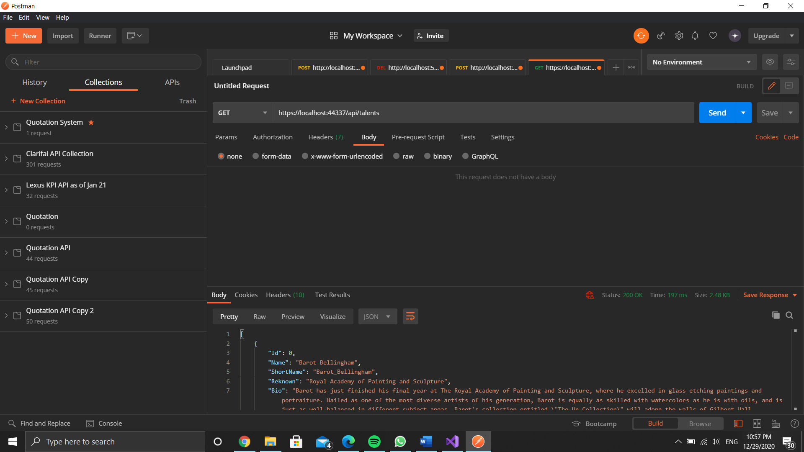

https://{hostname}:{port}/api/talents/{id}

Get talent’s details by ID

Return JSON stating talent’s name, shortname, reknown and bio

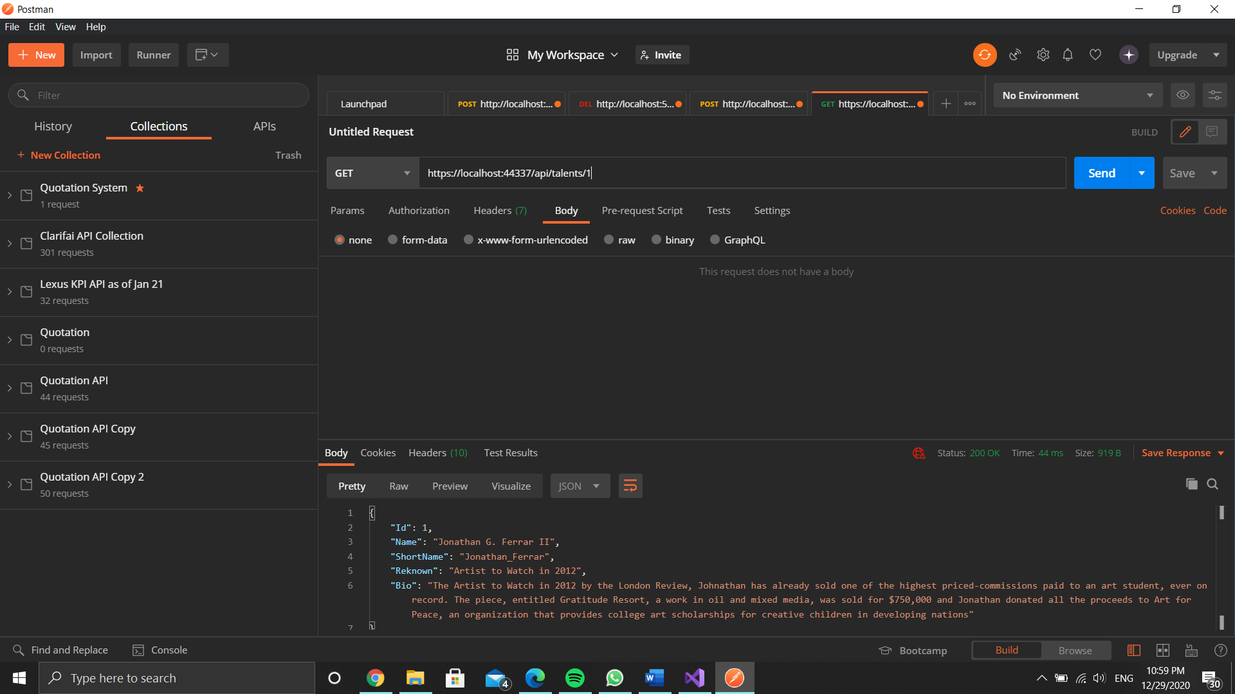

Accessing API using HTTP

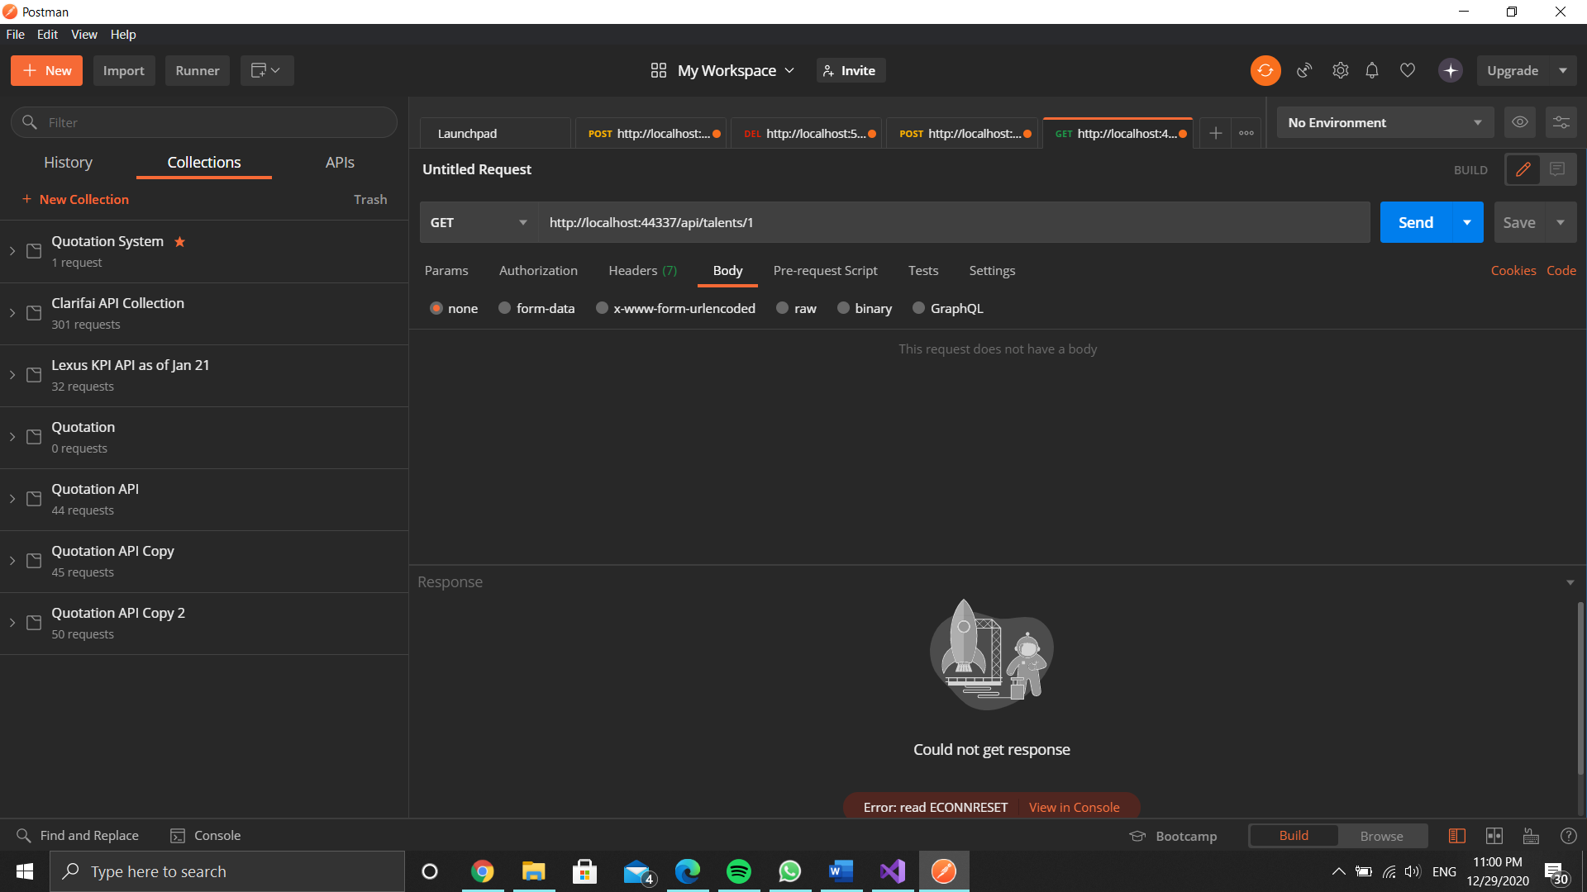

Sequence Diagram

